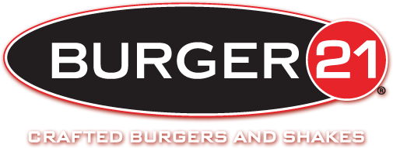Santiago Paz

Professor Von Deak

Section 003

February 20, 2015

I have read and understand the academic honesty policy as outlined in the syllabus and the student handbook. By affixing this statement to the title page of my paper, I certify that I have not cheated or plagiarized in the process of completing this assignment. If it is found that cheating and/or plagiarism did take place in the writing of this paper, I understand the possible consequences of the act/s, which could include, but are not limited to a ZERO for this assignment and a failing grade for the course

**Entrepreneurship**

Burger 21 was created in November 2009, when the owners of The Melting Pot Restaurants had a vision to create a burger chain that would serve high quality meals in a unique modern environment. The dream began with Mark Johnston, who tested several hundreds of burgers before creating and perfecting the 21 different selections of burgers we have today. Along with his wife, Arlene Johnston, they introduced a burger establishment that offered a quality menu able to meet the needs of the large foodservice industry. The first location was opened Westchase Florida November 2010.

Burger 21 has come a long way over half a decade; as of today there are currently fifteen stores in operation. Eleven of these are franchised while four are company owned. Meaning that eleven are owned by investors willing to assume the risk of the business, while Burger 21 operates the remaining 4. They began franchising in 2010, but weren’t able to open the first restaurant until 2011.

One of the biggest advantages for Burger 21 to begin franchising is to generate another source of income through fees and royalties. Most of the work is put onto the franchisee to generate success of franchise. Just like any other investor, franchisees want to get a good return on their investment, so they are always going to be motivated and driven to ensure their business is profitable. This brings up the point, which is the parent business is risking a little less than the franchisee, because most of the risk is put onto the investor to operate a successful unit. In case anything doesn’t go according to plan, the investor is forced to have $200,00 of liquid cash. A huge disadvantage of franchising would be unfavorable public relations. The parents companies don’t have a lot control of what the other franchises are doing, so they run risk of obtaining bad publicity, which affects all the other franchises, not just the one location. This will lead people to create a poor image of Burger 21’s brand as a whole. Unlike merging or acquiring, expansion would be very slow for the franchisor. Ideally, expansions are to be efficiently done in a certain amount of time. Franchising to individuals requires more time due to the start up as apposed to acquiring or merging an business already in operation

**International Business**

Even though Burger 21 is still a young company, it has a lot of potential, and expanding internationally it would allow it to reach this potential. A big plus of expansion into the global market would be increased brand awareness. Getting the company known will allow it to create a positive image around the world. Another plus of such a large expansion would be reaching a larger target market and obtaining a larger percentage of the market share. Finally, a big benefit of this would be more revenue.

Of course expanding internationally has its drawbacks. One of these would be the cost. It would require a lot of research in order to pin point which locations such a burger restaurant would be ideal. Also, there might not be acceptability in all parts of the world. Foreign investment is one of the biggest risks since there isn’t as easy access as there would be if the store were located domestically. Another minus would be spin offs of the franchise, since laws and regulations are different across the rode. There are a lot of implications that come with expanding internationally. Different parts of the world have different cultures, so burger 21 would have to adapt to different regions of the world. There are a lot of regulations that burger goes through by the FDA, but it wouldn’t end there if the company expanded. The franchise would have follow domestic as well as foreign regulations. Another implication would be liability issues that the company could run into such as allergies or religious restrictions that prevent people from consuming their food.

**Operations Management**

According to the Burger 21 Franchisee kit, “Burger 21 takes advantage of a centralized ordering, distribution, and re-distribution process through its existing network of partners currently used by its affiliate, The Melting Pot Restaurants, Inc.” (Burger 21, 7). One of the benefits of having a centralized authority of decision-making is a lower cost since there is a single team of management that makes the decisions. Typically, they are the ones with conceptual skills who don’t interact with subordinates. This could be a drawback since they don’t know what truly is going on day to day at each location. A decentralized team could be more capable of making decisions for the company, since the managers from that teamwork in a smaller scale. They are living and experiencing direct sales with customers, so they know what small changes need to be made that could possibly have a huge impact.

**Finance**

In order to become a proud owner of a Burger 21 franchise the total investment start at around $422,083 and reaching up to $974,395. The franchise fee is $40,000 and the term of franchise agreement is 10 years, which can be renewed. In order to be an owner you need to have a net worth of at least $500,000 with $200,00 liquid cash. The franchisee must pay a monthly royalty fee of 5% .The marketing fee is .75% to advertising fund, and 3% has to be spent on a local level.

**Management**

Burger 21 is like any other company with its own strengths, weaknesses, opportunities, and threats. Strengths for burger 21 include its history of food management through The Melting Pot Restaurants, Inc. These owners used their knowledge and experience of burgers into the franchise that exists today. It also has a cost advantage since it does have a centralized authority of decision-making. It will reduce the costs by cutting down the number of managers required to organize, lead, plan, and control each unit. Although it’s fast casual, the service is excellent. When I visited one of locations I was cared for by “mover”, similar to a waiter, who checked on my table to ensure I was enjoying the food. The company also has a possibility for weaknesses too. One factor that would lead to a weak franchise would be an inexperienced franchisee. Burger 21 prefers experiences franchisees, so one who doesn’t know the business could lead the unit into bankruptcy. There could also be a possibility of a narrow product line. Meaning that people could get tired of the same burgers. Finally, if Burger 21 doesn’t market their brand enough, their franchise will not receive appreciation. There are big opportunities for any franchise, and Burger 21 is a candidate that can take advantage of them. Instead of serving domestically, they can expand across its borders and beyond. After claiming the king of burger throne, they can add additional cuisines that will make customers want to return. If there is more acceptability, the company could experience such exponential growth that it could possibly allow it to go public. Threats could interfere with such opportunities. One big threat could be research findings on beef that the industry has been using, that aren’t favored by customers, which would lead a decrease in demand. Dealing with food is always difficult especially beef. Burger 21’s responsibility is to ensure their burgers are cooked to a degree with no potential fatal diseases. One single person becoming sick from a meal there could result in a lawsuit. Another threat it’s vulnerable to is change in wage rate. This would require the firm to evaluate and reorganize its costs in order to remain profitable. Burger 21’s culture is different in that it provides a dining experience that other burger places that I have visited such as Shake Shack, Five Guys, or Smash Burger.

**Human Resource**

Some of the steps that must be followed in order to become a franchisee include having experience in single and multi-unit operations. This doesn’t necessarily mean you can’t own one if you don’t have the experience, Burger 21 simply prefers those who have a background in the field. This is because they are looking for someone who already has proven him or herself to be successful in their previous operations and is actively seeking to diverse their portfolio of investments. One of the main reasons why they prefer someone with experience is because he or she will be an asset to Burger 21 instead of a liability. The next step of becoming a franchisee possesses the abilities and resources to open an additional unit. Whether or not it is necessary to expand is discussed only with Burger 21’s Franchise Development team. Money isn’t the only requirement to become a franchisee; you need to also be passionate and committed to exceptional customer service. These characteristics are crucial to the success of any business. You must also have a liquidity of $250,000 and net worth of $600,000 per unit of interest.

Owning a franchise opens a large window of opportunities. Opening a business that already has brand recognition reduces risk of failure, and almost guaranteed profits since customers already know what to expect. Burger 21 as well as other franchises provides excellent training, systems, and support. Training will provide assistance in everything from the grand opening to ongoing training that is designed to educate the owner of the daily operations that go into maintaining the unit.

**Excel**

The competitor I chose was The Cheesecake Factory. Although they have many locations they don’t franchise the company owns any, all locations. Advantages of franchise ownership will still produce profits similar to non-franchised locations. A disadvantage would be not having as much control as company owned locations. If it’s company owned, the company ultimately can make decisions that they know will be successful from past experience.

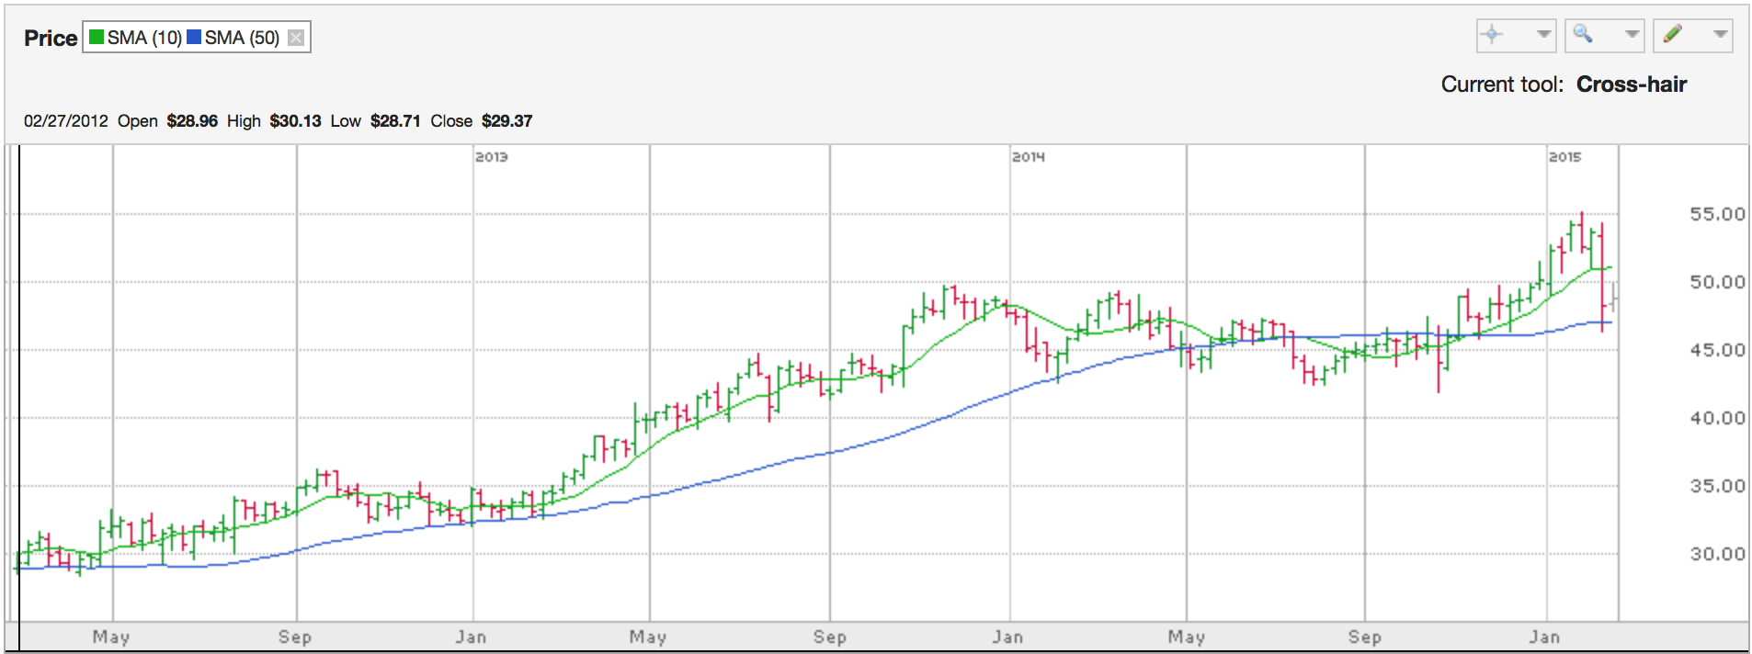

Works Cited

"Burger 21." *Burger 21 Our Story Comments*. N.p., n.d. Web. 20 Feb. 2015. <http://www.burger21.com/our-story/>.

"Burger 21 Franchise Information." *Entrepreneur*. N.p., n.d. Web. 20 Feb. 2015. <http://www.entrepreneur.com/franchises/burger21/334121-0.html>.

"Burger 21 Restaurant Franchise ." *Restaurant Franchise*. N.p., n.d. Web. 20 Feb. 2015. <http://www.burger21franchise.com/ReasonstoInvest.aspx>.

"Centralized Vs. Decentralized Organizational Design." *Small Business*. N.p., n.d. Web. 20 Feb. 2015. <http://smallbusiness.chron.com/centralized-vs-decentralized-organizational-design-11476.html>.

*Different*. N.p.: John Wiley & Sons, 2006. Web.

"Top 10 Reasons To Buy a Franchise." *Entrepreneur*. N.p., 27 Dec. 2007. Web. 19 Feb. 2015. <http://www.entrepreneur.com/article/188452>.

"Top 10 Reasons To Buy a Franchise." *Entrepreneur*. N.p., 27 Dec. 2007. Web. 19 Feb. 2015. <http://www.entrepreneur.com/article/188452>.